 |  |  |  | 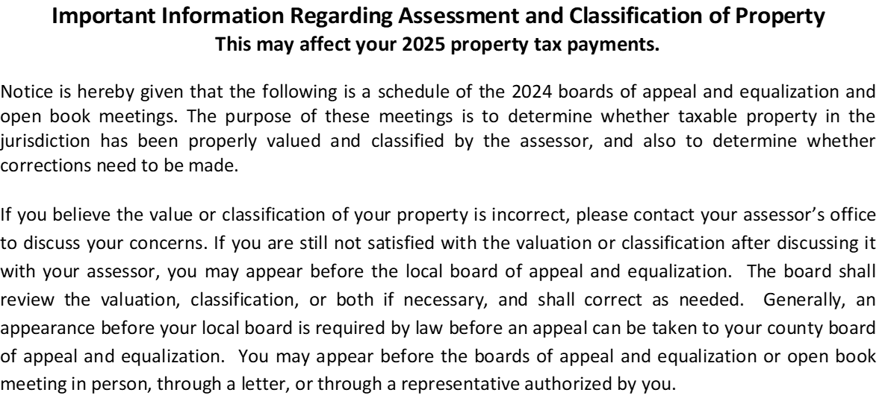
Date |  | TOWNSHIP/CITY |  | LOCAL BD/OPEN BK | TIME | LOCATION
May 14 & 15, 2024 |  | Bear Creek Township |  | Open Book | 9:00 AM - 4:00 PM | Assessor's Office
May 14 & 15, 2024 |  | Copley Township |  | Open Book | 9:00 AM - 4:00 PM | Assessor's Office
May 14 & 15, 2024 |  | Dudley Township |  | Open Book | 9:00 AM - 4:00 PM | Assessor's Office
May 14 & 15, 2024 |  | Eddy Township |  | Open Book | 9:00 AM - 4:00 PM | Assessor's Office
May 14 & 15, 2024 |  | Falk Township |  | Open Book | 9:00 AM - 4:00 PM | Assessor's Office
May 14 & 15, 2024 |  | Hangaard Township |  | Open Book | 9:00 AM - 4:00 PM | Assessor's Office
May 14 & 15, 2024 |  | Itasca Township |  | Open Book | 9:00 AM - 4:00 PM | Assessor's Office
May 14 & 15, 2024 |  | LaPrairie Township |  | Open Book | 9:00 AM - 4:00 PM | Assessor's Office
May 14 & 15, 2024 |  | Leon Township |  | Open Book | 9:00 AM - 4:00 PM | Assessor's Office
May 14 & 15, 2024 |  | Minerva Township |  | Open Book | 9:00 AM - 4:00 PM | Assessor's Office
May 14 & 15, 2024 |  | Moose Creek Township |  | Open Book | 9:00 AM - 4:00 PM | Assessor's Office
May 14 & 15, 2024 |  | Nora Township |  | Open Book | 9:00 AM - 4:00 PM | Assessor's Office
May 14 & 15, 2024 |  | Pine Lake Township |  | Open Book | 9:00 AM - 4:00 PM | Assessor's Office
May 14 & 15, 2024 |  | Popple Township |  | Open Book | 9:00 AM - 4:00 PM | Assessor's Office
May 14 & 15, 2024 |  | Rice Township |  | Open Book | 9:00 AM - 4:00 PM | Assessor's Office
May 14 & 15, 2024 |  | Shevlin Township |  | Open Book | 9:00 AM - 4:00 PM | Assessor's Office
May 14 & 15, 2024 |  | Sinclair Township |  | Open Book | 9:00 AM - 4:00 PM | Assessor's Office
May 14 & 15, 2024 |  | Winsor Township |  | Open Book | 9:00 AM - 4:00 PM | Assessor's Office
May 14 & 15, 2024 |  | Long Lost Lake Township |  | Open Book | 9:00 AM - 4:00 PM | Assessor's Office
May 14 & 15, 2024 |  | Unorganized Township |  | Open Book | 9:00 AM - 4:00 PM | Assessor's Office
May 14 & 15, 2024 |  | Bagley City |  | Open Book | 9:00 AM - 4:00 PM | Assessor's Office
May 14 & 15, 2024 |  | Clearbrook City |  | Open Book | 9:00 AM - 4:00 PM | Assessor's Office
May 14 & 15, 2024 |  | Gonvick City |  | Open Book | 9:00 AM - 4:00 PM | Assessor's Office
May 14 & 15, 2024 |  | Leonard City |  | Open Book | 9:00 AM - 4:00 PM | Assessor's Office
May 14 & 15, 2024 |  | Shevlin City |  | Open Book | 9:00 AM - 4:00 PM | Assessor's Office
May 7, 2024 |  | Greenwood Township |  | Local Board | 6:00 PM | Town Hall
May 17, 2024 |  | Clover Township |  | Local Board | 6:00 PM | Town Hall
May 21, 2024 |  | Holst Township |  | Local Board | 7:00 PM | Town Hall
All OPEN BOOK meetings will be held at the Clearwater County Courthouse - Assessor's Office.
COUNTY BOARD OF APPEAL & EQUALIZATION will be held June 18, 2024 at 6:00pm in the County Board Room.

